International Network for School Social Work

http://internationalnetwork-schoolsocialwork.htmlplanet.com

Contact mhuxtable@olympus.net



Electronic Newsletter August 2008
Editor: Marion Huxtable

Fourth International School Social Work Conference

The Fourth International School Social Work Conference will be held in New Zealand in April 2009. At http://4isswc.massey.ac.nz/ you can find details about the conference and how to send in an abstract to present a paper.
2009 will mark the 20th anniversary of passage of the United Nations International Declaration on the Rights of the Child. The conference will provide an opportunity to explore how social work in schools has contributed to fostering children's rights and how this objective can be further enhanced in the third decade of the declaration.
All member nation states of the United Nations, except the US and Somalia, have ratified the Declaration. http://en.wikipedia.org/wiki/Convention_on_the_Rights_of_the_Child. The Declaration has 10 principles, covering all aspects of children’s rights, all of which apply to the rights of children in school. The Declaration includes the right to education for all children and for specialized education for children who have physical, mental or social disabilities.

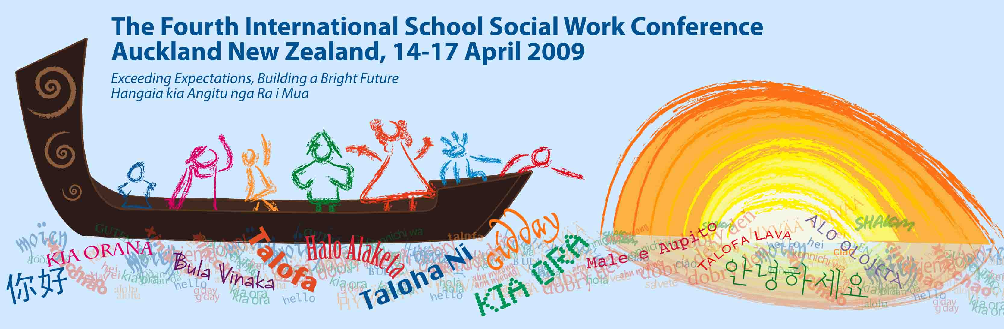

Maori Medium Education

Maori medium education programmes involve students being taught either all or some curriculum subjects in the Maori language, either in immersion (Maori language only) or bilingual programmes (Maori and English). This index page provides links to data on Maori Medium Education. In July 2007, there were 28,490 students involved in Maori-medium education.
http://www.educationcounts.govt.nz/statistics/schooling/july_school_roll_returns/6040

Learn te reo Maori

If you plan to attend the conference, this is a good time to learn some te reo Maori (Maori language), so that you will be ready to reply to the friendly greetings and able to pronounce some of the names and places correctly. Even if you are not able to attend, here is a chance to learn about Maori culture and language.

Listen to the New Zealand National Anthem to get a taste of the language:
E Ihowa Atua - New Zealand National Anthem
http://www.youtube.com/watch?v=Z2ToGR1Sb98

If you are a rugby fan, listen to the National Anthem at an All Blacks test match
http://www.youtube.com/watch?v=An5Hyoq-lXQ&feature=related

Now you are ready to learn some words in te reo Maori from this web site - http://www.nzhistory.net.nz/culture/maori-language-week/100-maori-words - where you can read the words and listen to them. The language is phonetic and easily pronounced.

If conference manuhiri (guests) study the word list, you will hear and understand the phrase “Nau mai, haere mai!” (Welcome!) from the tangata whenua (people of the land). “Kia ora” is the every day greeting. You could greet the audience with “Tena koutou” if you are giving a talk at the conference.

Count from one to ten and listen to the pronunciation of each word at http://www.maori.org.nz/kotereo/default.asp?pid=sp149&parent=115
Tahi, rua, toru, wha, rima, ono, whitu, waru, iwa, tekau

Kia ora

